

***Department of Computer Science & Engineering***

**Course Title –** Software Engineering

**Course Code –** CSE 322

**Section** - A1

Diagrams Part - 1

***Laptop Recommendation system using NLP***

**Date of Submission –** March 23, 2022

**Submitted by:**

Md. Hasibur Rahman (19101009)

Tanmoy Mazumder (19101013)

Shawan Das (19101020)

**Submitted to:**

Dr. Shah Murtaza Rashid Al Masud

Associate Professor,

University of Asia Pacific

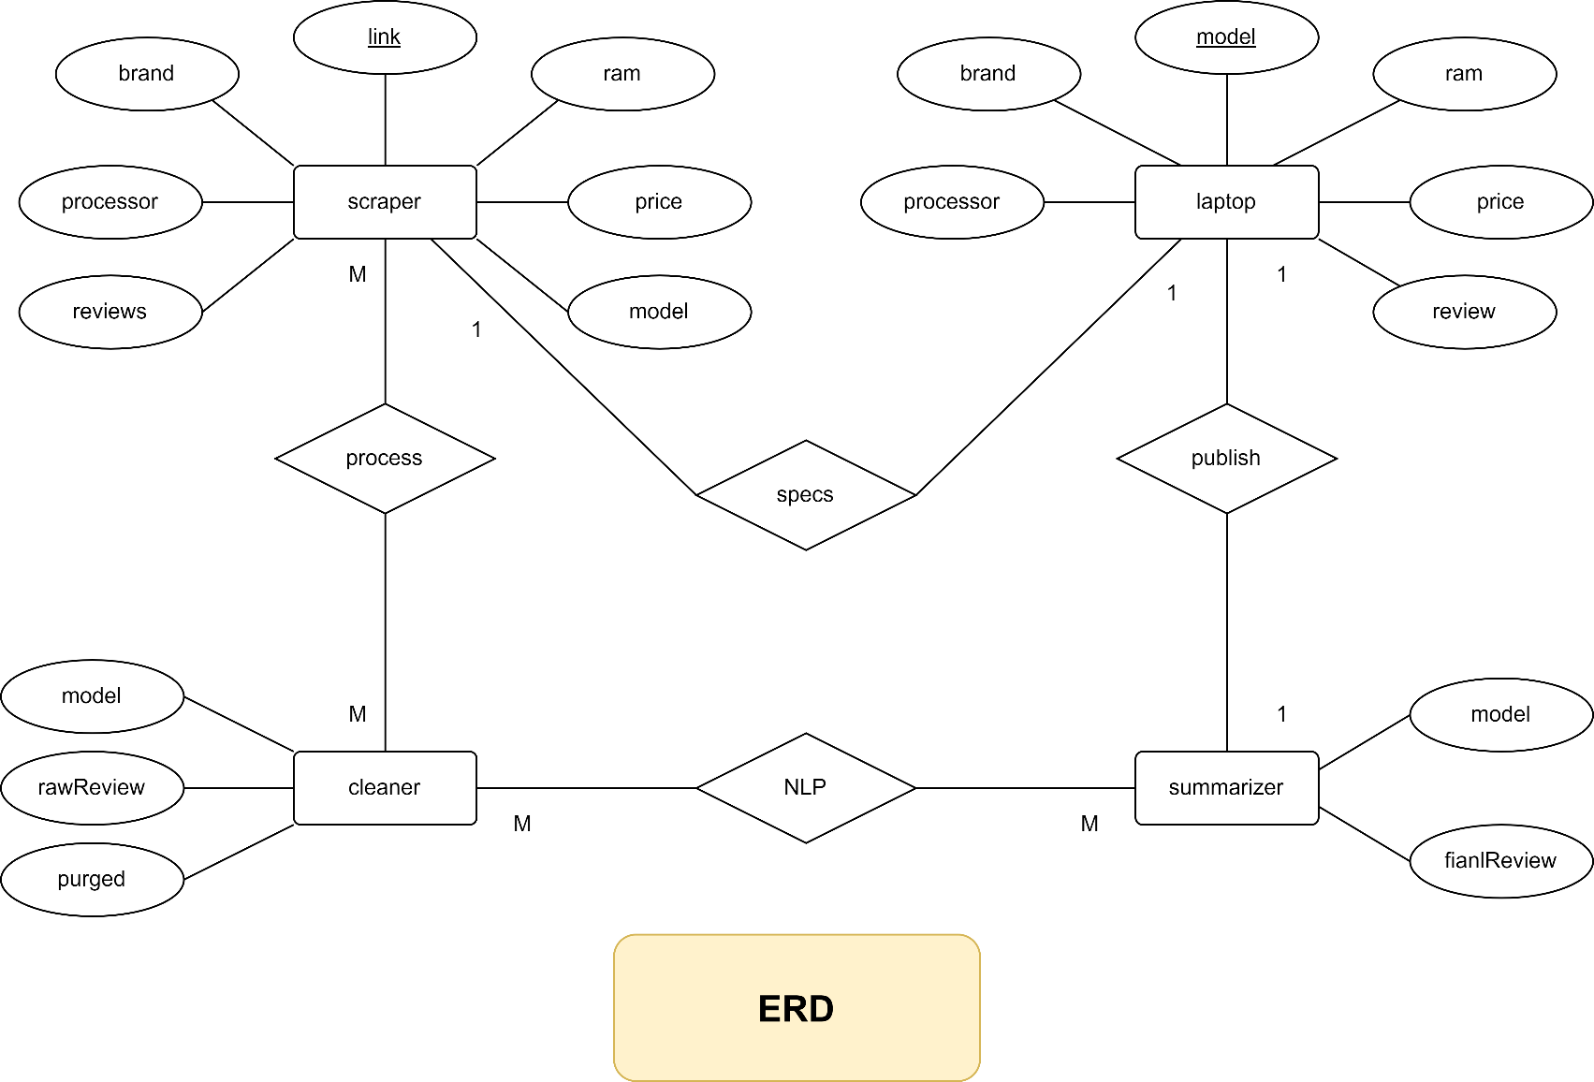Entity Relationship Diagram

­­­

Description:

There are 4 entities: Scraper, Cleaner, Summarizer, Laptop.

1. Scraper: The Scraper goes over each of the laptop’s review pages and collects information such as the model, reviews, price, brand, ram, and processor.
2. Cleaner: The cleaner processes the raw reviews collected by the scraper, purges the collected data of any unwanted portions that are hindrances to the NLP model’s functionality, and creates clean and usable versions of each review.
3. Summarizer: The summarizer comprises of the NLP model and the final review for the given laptop.
4. Laptop: This is the general entity for each of the laptops in the database. It holds the basic info from the scraper and the final review from the summarizer.

ERD Relations:

|  |  |  |  |
| --- | --- | --- | --- |
| **Entity A** | **Entity B** | **Relation** | **Type** |
| Scraper | Cleaner | Process | Many to many |
| Cleaner | Summarizer | NLP model | Many to many |
| Summarizer | Laptop | Publish | One to one |
| Laptop | Scraper | Specs | One to one |

Use Case Diagram

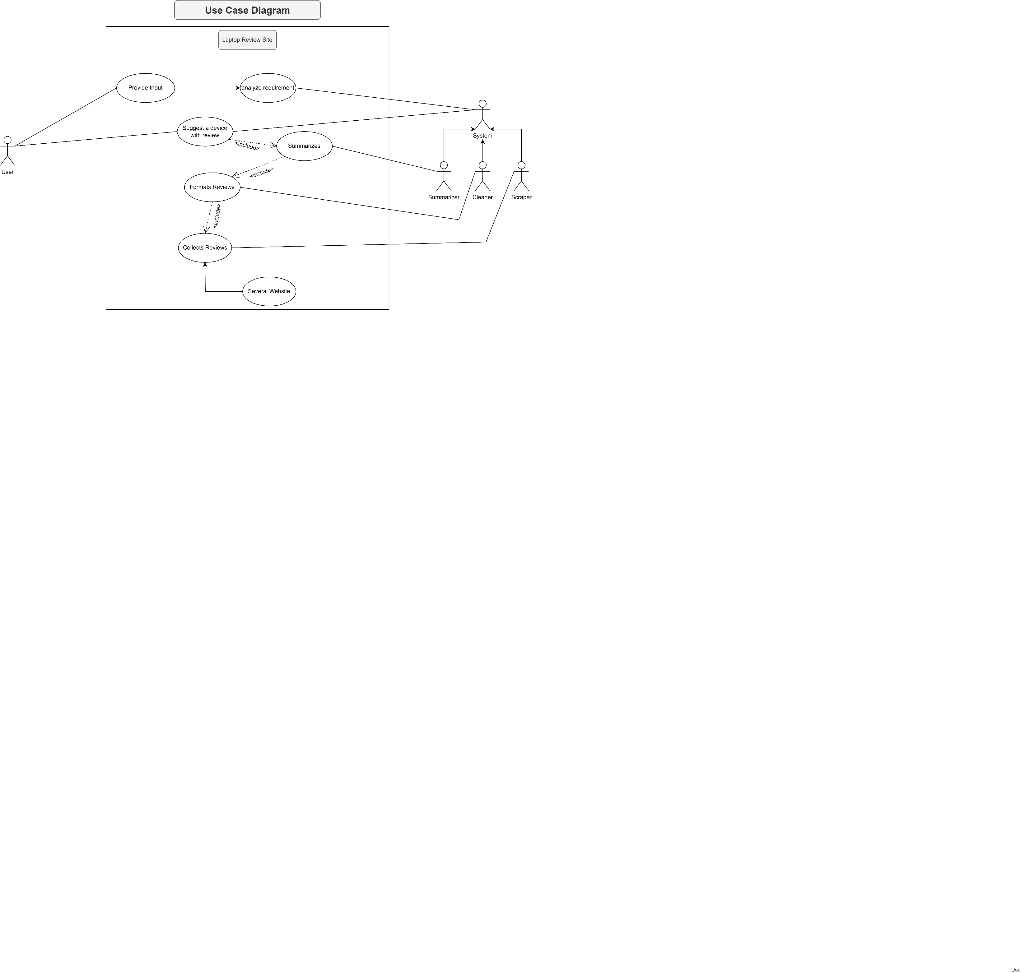

Description:

There are 2 actors: The User and The System(admin). They interact through the website.

The user provides input about what type of laptop they are looking for and then waits for the output. The input would then be analyzed by the system and it would provide suggestion by matching the best fit available from the summarized reviews.

These summarized reviews are the products of the subsystem Summarizer. The summarizer uses the multiple cleaned reviews provided to it by the Cleaner subsystem.  
The Cleaner subsystem is responsible for creating clean-formatted reviews from the raw reviews collected for each laptop.

The raw reviews are collected by the Scraper subsystem. The Scraper runs on the multiple links of review sites.

Following this process chain, the output suggestion would be created and provided to the user.

Activity Diagram

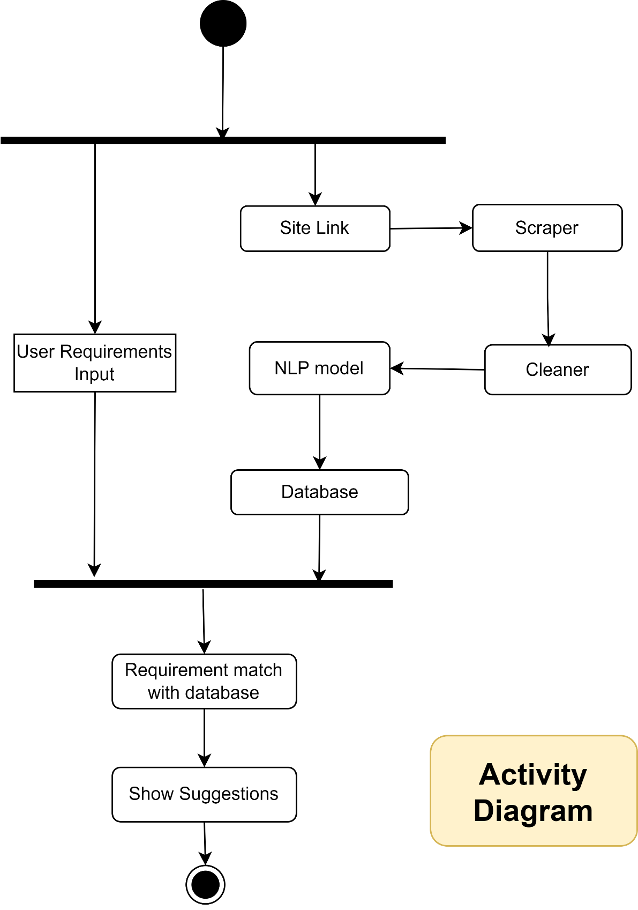

Description:

Each day, at a certain point in time, the system will run its scraper, cleaner, and NLP model’s summarizer in sequence to update the database.

Whenever a user uses the system and inputs their requirements, the system would run the request with the requirements parameters and match it with available laptop models and their review from the latest updated database. Once the system produces a result, it would be the output.